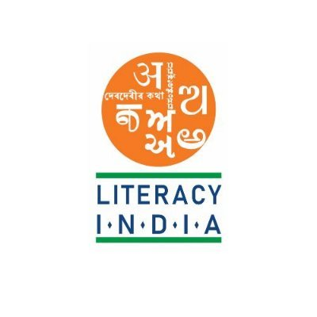

**Programes Offred**

* **Robotics/tinkering**
* **Computer Hardware**
* **Mobile repairing**
* **Cooking/hospitality**
* **Beauty and wellness**
* **Stiching and cutting**
* **Electrical troubleshooting**
* **Two-wheeler Repairing**
* **Mobile journalism**
* **Computer science**
* **Call centre/BPO**
* **Logistics**
* **Data Digitization**
* **Natural Farming Market Connect**
* **Banking**

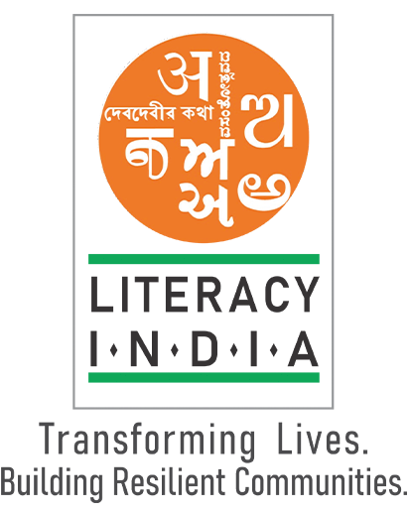

Literacy India Community College (LICC)

Hir6jf

[WWW.literacyindia.org](http://WWW.literacyindia.org)

Session starts

From January 2024

Contact no - 8588853380

Limited Seats

Register Now